**IICS — ROUTER**

* Go to the respective project folder .
* Click new — Click Mappings — Create a mapping to deploy data integration logic that is processed on the secure agent.
* Change the Mapping name.
* Click on Source — Go to Source in the properties — Select the connection — Source type Single — Select the object/table (SALES DETAILS).
* There are many Transformation available in the Mapping — Sorting, Joiner, Router etc.
* In this project the Router is used to load data from 1 Source file to 3 Target files — Adding a new Column called Full Name.
* Drag and Drop the Router Transformation.
* Click on Router — Go to Output Groups in the properties — Add 1 each Condition for 3 different Target files — Condition 1 — SALES_YEAR = 2020, Condition 2 — SALES_YEAR = 2021 Condition 3 — SALES_YEAR = 2022
* Click on Target — Go to Target in the properties — Select the connection — Source type Single — Create the object/table.
* Save and Run

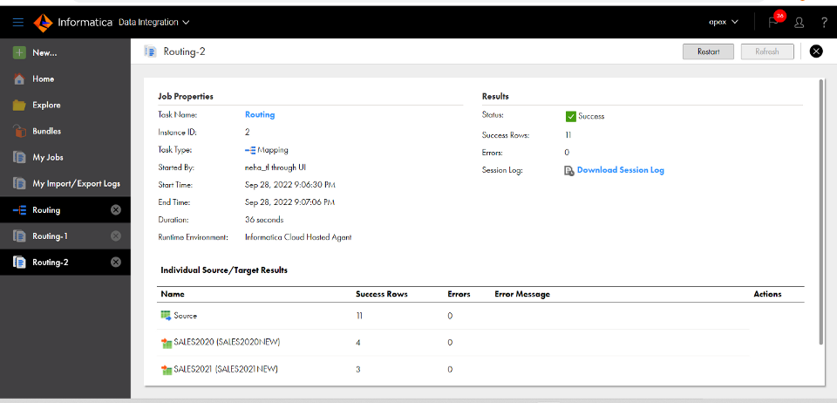

IICS — ROUTER

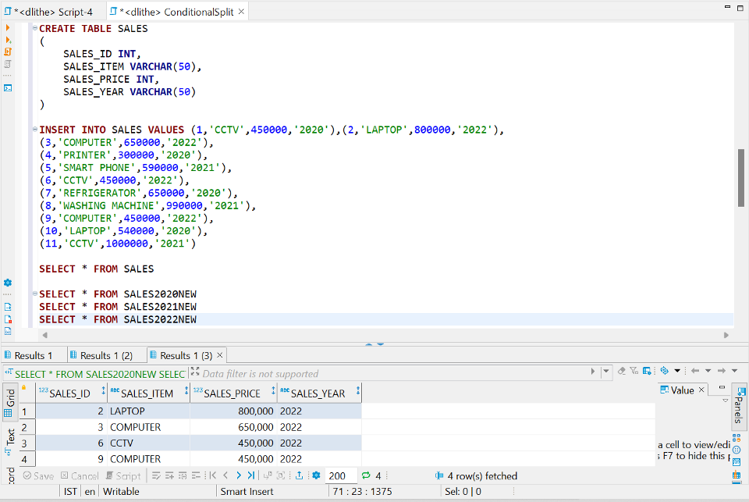

*1 SOURCE TO 3 SEPERATE DESTINATION ACCORDING TO THE CONDITION*